**Bugs Reported:**

**UAT UNIT TEST CASE Specification**

**Bug 01**

Balance does not increase upon winning each match:

**Test 01 – Balance does not increases**

**Purpose:** The test confirms that the bug is present

**Pre-Condition:**

Player object instantiates

Player has minimum balance required for the bet

**Data Required:**

Player object with parameters name and balance

**Results:**

|  |  |  |
| --- | --- | --- |
| **Date/Time** | **Tester** | **Status** |
| 26/10/2015 | Shailesh Jha | Unit Test Failed – Bug Exists |

**Bug 02**

Betting limit of zero cannot be achieved. Remaining balance is 5

**Purpose:**

Reproduce the buggy behavior by instantiating Player object with parameters name and balance and then calling the *Player.balanceExceedsLimitBy* method .

**Pre - Condition:**

Player object instantiates

Player has minimum balance required for the bet

**Post-conditions:***Player.balanceExceedsLimitBy()* method is called reproducing the buggy behavior.

**Data Required:**

Player object with parameters name and balance

**Results:**

|  |  |  |
| --- | --- | --- |
| **Date/Time** | **Tester** | **Status** |
| 26/10/2015 | Shailesh Jha | Unit Test Failed – Bug Exists |

**Bug 03**

The of game win:loose does not have the 8%bias. The probability should be approximately 0.42.

**Pre - Condition:**

Dice object instantiates

Number of times value rolls

**Post - Condition:**

NA

**Data Required:**

Dice Object and probability count

**Results:**

|  |  |  |
| --- | --- | --- |
| **Date/Time** | **Tester** | **Status** |
| 26/10/2015 | Shailesh Jha | Unit Test Failed – Bug Exists |

**Debugging Log:**

**Bug 01**

Balance does not increase upon winning each match:

**Trace Error:**

* Check *Player.receiveWinnings* method

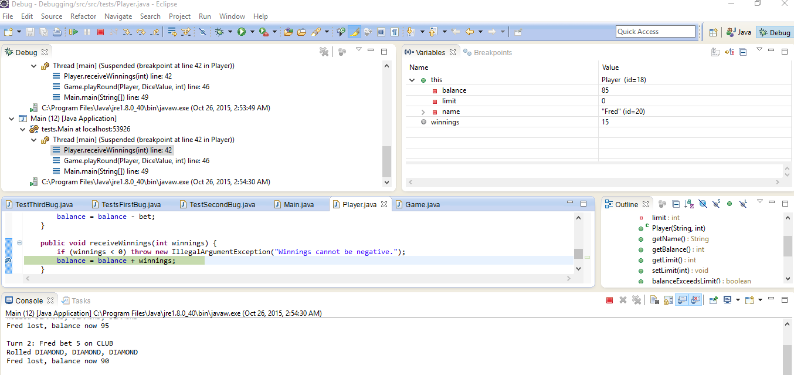

* Check Game *Game.playRound* method

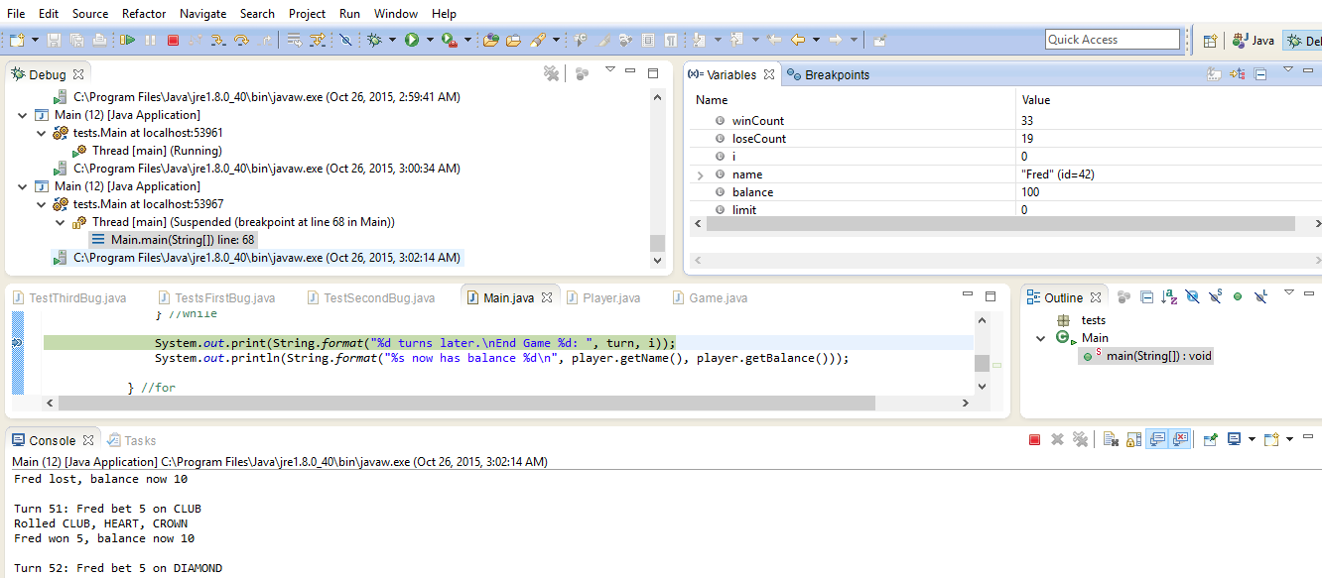

**Bug 02**

Betting limit of zero cannot be achieved. Remaining balance is 5

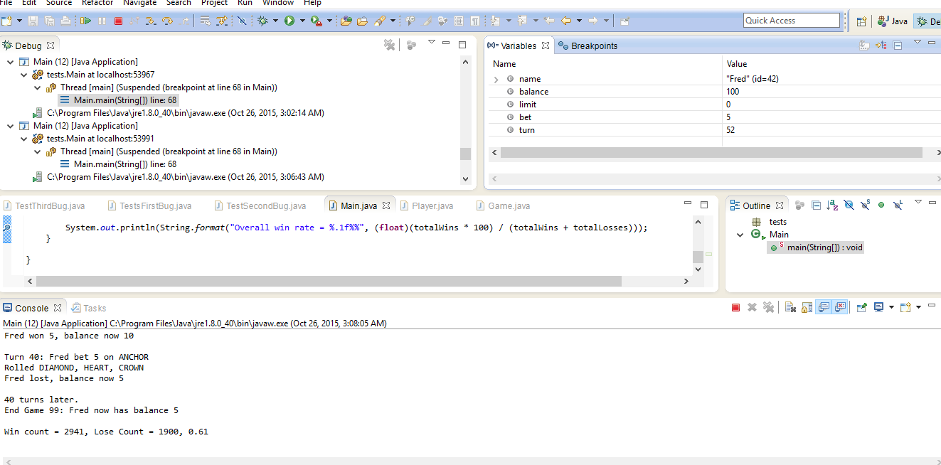

**Trace Error:**

Check *Player.takeBet* method

Check *Player.balaceExceedsLimitBy* method

**Following code needs updating:**

**public** **boolean** balanceExceedsLimit(**int** amount) {

**return** (balance - amount > limit);

}

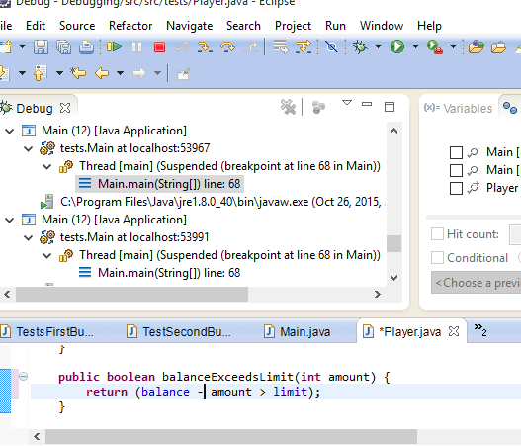

**Bug 03**

The of game win:loose does not have the 8%bias. The probability should be approximately 0.42.

**Trace Error:**

Initially unable to trace as 0.40is pretty close although the Junit test case fails:

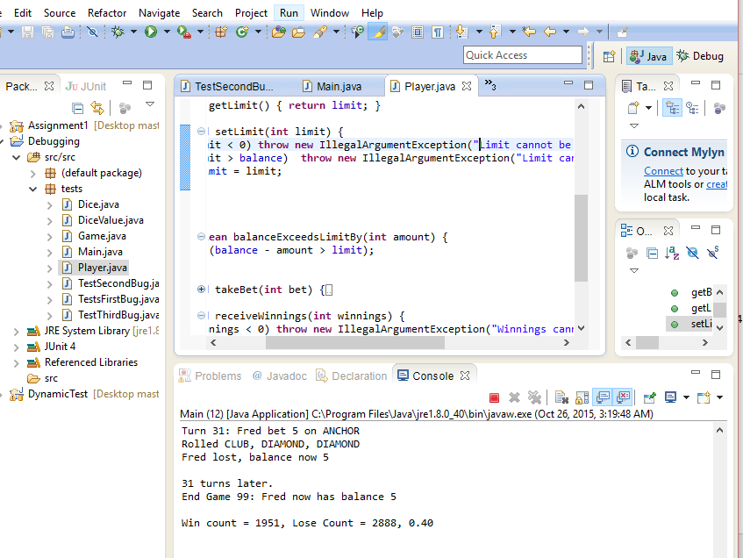

**Junit Test Case Results Screenshots:**

**Bug 01:**

Balance does not increase upon winning each match:

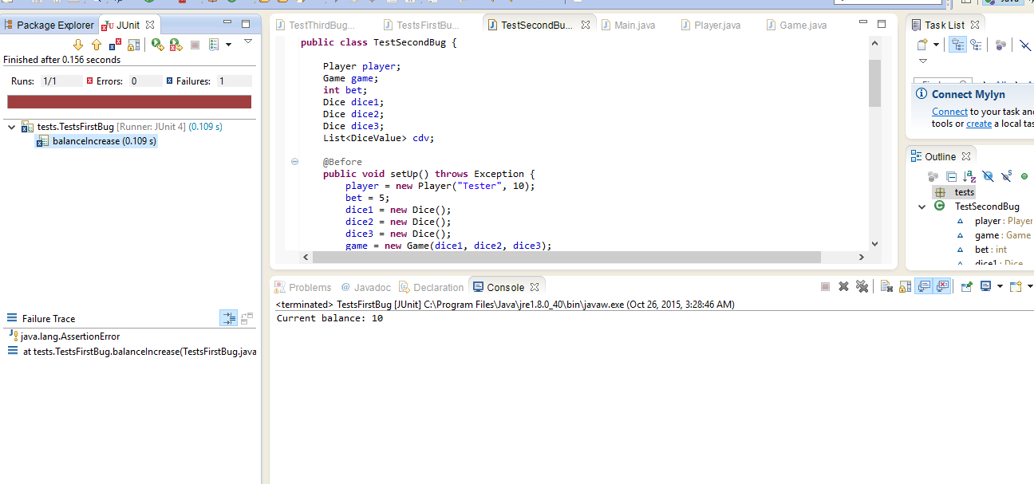

**Bug 02**

Betting limit of zero cannot be achieved. Remaining balance is 5

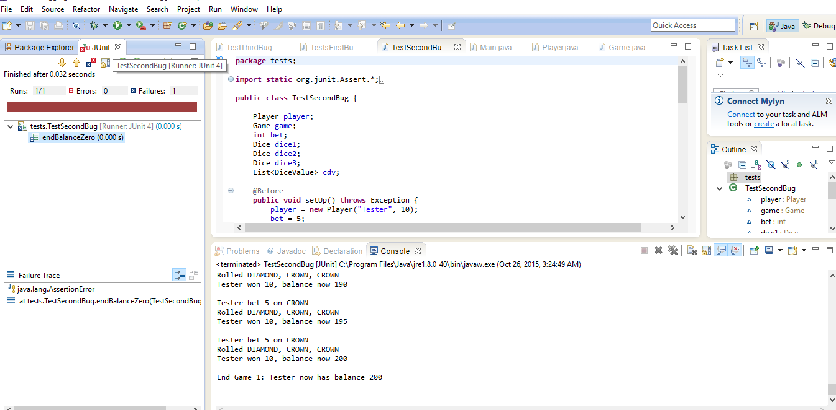

**Bug 03**

The of game win:loose does not have the 8%bias. The probability should be approximately 0.42.

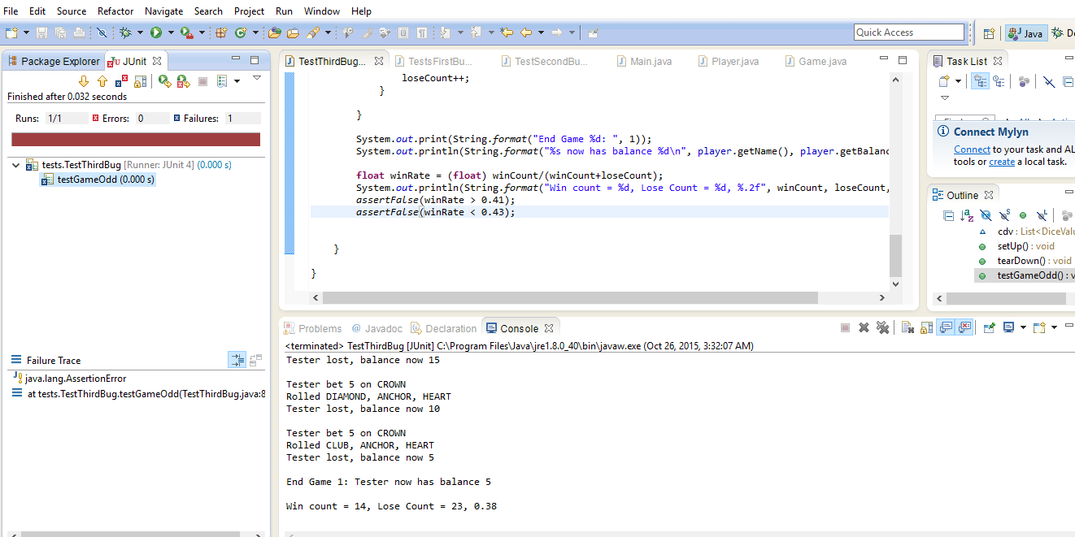

**Resolution:**

Automated result screenshot:

**BUG 01**

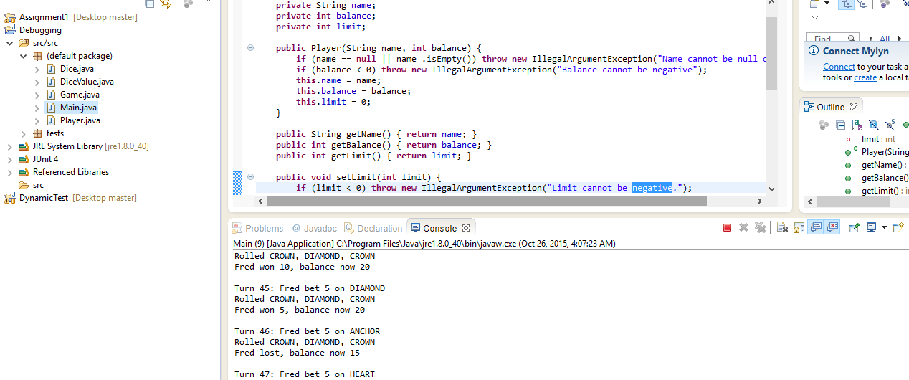

**BUG 02**



**BUG 03**

